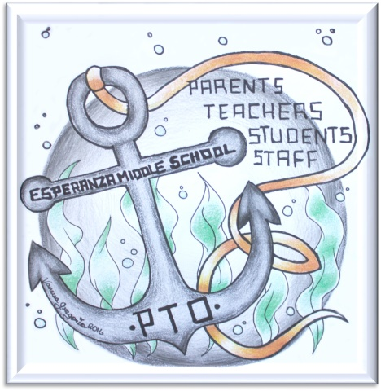
Esperanza Middle School PTO
General Meeting
6pm Tuesday January 17th 2017
EMS Media Center

- Meeting called to order by president Virginia Richardson at 6:05pm

- Attendance -10 members

- Approval Of GM Minutes – Motion made to dispense with reading Tuesday 14th September 2016 minutes as had been emailed out. Approved.

- Board Members Update

- Old Business
- Spirit Nights: Chick-fil-A - $403, Sweet Frog/Pot Belly combo - $68.50 & $163.50. Traffic incidents both nights affected attendance.
- School Dance: October 28th Fall Dance (ELA). Thank you to volunteers.
- Committees Established: Lost & Found – Linda Ferm, Spirit Nights – Paula Ross, Staff Appreciation Meals – Nancy Bobrowski
- Appreciation Days & Weeks: Bus Driver Appreciation Week (Oct). Staff Appreciation meals to be held on early dismissal days to allow staff to eat together and relax.
- Student representatives & Involvement: Gracelyn Casas present at meeting.
- CASH Training: Now online.

- New Business
- Current Treasurer’s Report: Tina Miller. Current balance $1661.99
Upcoming expenses: Non Profit Status (one time fee) $750. Insurance & PTO Today Membership $700
Upcoming Income: PTO March Dance, 2 spirit nights, Shoebox Recycling
- Board Members for 2017/18: Possible nominees include: Paula Ross, Kristal Willis, Ann Buckler.
Ann Buckler to step in as Vice President for remainder of 2016-17 year. Unanimously voted in.
- Spirit Nights: Chipotle 5-9pm February 13th, Brusters April 5th
- School Dances:
  - Jan 20th Social Studies 2:30-4pm
  - Feb 17th Math 2:30-4pm
  - March 24th PTO Dance 6:30-8pm
  - No dances April-Jun aside from 8th grade dance.
- PTO Dance: March 24th 6:30-8pm. Volunteers needed for games and chaperoning. Theme to be voted on by students; either Sock Hop or Comic-Con. Gracelyn explained students’ ideas for themes. Dance committee to be formed.
6. Appreciation Weeks & Days:
  - Teacher & Staff Appreciation Week: May 1st-5th
  - Next Staff Appreciation Lunch: February 7th. Sign up link to go out on Facebook, website and via email.

7. Representatives & Involvement:
a. Current Representatives: Gracelyn Casas, Samantha Abell, Ellie Geiger, Isabella Dever, Tyler Arends
b. Name the Pirate Contest: Voting by students, managed by PBIS, going on now. Results should be out soon.
c. 2017-18 Agenda cover artwork contest. In progress via art teacher, Ms Read. Winner to receive an agenda, t-shirt and $50 cash.

8. Special Events:
a. 8th Grade Staff –Student Annual Basketball Game. Date to be set.
b. Special Event Assembly (and fundraiser) More details to follow
c. Tie Dye Fundraiser. Probably in April. $10 per t-shirt (making a profit of $5 a t-shirt)
9. Non Profit Status: Should be in place by end of school year.
10. Door Prize Drawing: $15 gift card to Linda Ferm

- Meeting adjourned at 7:06pm. (Next PTO General Meeting in April 2017 TBD)

- Minutes compiled by Tracy Clinning-Noel, PTO secretary

