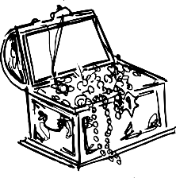
CALL FOR NOMINATIONS
We are looking for EMS PTO Board members for the 2020-2021 school year. The PTO is a great way to make a difference at Esperanza Middle School. The PTO depends on amazing parents to be successful. The PTO Nominations will be held in April at the PTO General Meeting. Please fill out the form below if you or someone you know is interested in being part of this great team. You can send the form in with your child in an envelope marked PTO or email the information to esperanzamspto@gmail.com
Please place a check by the position you are interested in. If you are flexible you can put #1, #2, and #3 by the position.
President _____ Vice President _____ Treasurer _____ Secretary _____
Parent Nominee’s name__________________________________ Child’s name____________________
Phone # & E-mail______________________________________________________ Child’s grade______
Serve on the following committee(s) (Co-Chairs):
___ Teacher Luncheons Chair (3 luncheons a yr.) ____PTO Dance Chair (4 Dances per year)
___Teacher B2School/Appreciation Week ___ Bus Driver Appreciation Day ___Custodians Day
Chairperson

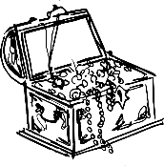
CALL FOR NOMINATIONS
We are looking for EMS PTO Board members for the 2020-2021 school year. The PTO is a great way to make a difference at Esperanza Middle School. The PTO depends on amazing parents to be successful. The PTO Nominations will be held in April at the PTO General Meeting. Please fill out the form below if you or someone you know is interested in being part of this great team. You can send the form in with your child in an envelope marked PTO or email the information to esperanzamspto@gmail.com
Please place a check by the position you are interested in. If you are flexible you can put #1, #2, and #3 by the position.
President_____ Vice President _____ Treasurer _____ Secretary_______
Nominee’s name___________________________________ Child’s name_________________________
Phone # & E-mail_____________________________________________________ Child’s grade_______
Serve on the following committee(s) (Co-Chair):
___ Teacher Luncheons Chair (3 luncheons a yr.) ___PTO Dance Chair (4 Dances per year)
___Teacher B2School/Appreciation Week ____ Bus Driver Appreciation Day ___Custodians Day
Chairperson

